# **Recession’s Impact on Housing Prices**

Haritha Dhanlalji Parmar

Vyshnavi Reddy Mungi

Department of Computer Science, School of Science and Engineering

Saint Louis University

220 N Grand Blvd, St. Louis, MO 63103

Introduction to AI

Professor Mohammad Yavarimanesh

March 6th, 2023

## Recession’s Impact on Housing Prices

The housing market in the United States has long been seen as a key sign of the health of the national economy. The global economic crisis that started in 2008 had a substantial impact on the housing market, leading to a sharp decline in property values in a number of locations. Due to the decline in property values, many people saw their biggest investment lose value, which led to bankruptcies, foreclosures, and a wave of economic instability.

The examination of the effects of the recession on the US housing market in this project report contributes to that goal. We will look at the trajectory of property prices before and after the crisis to understand the severity of the fall and how it affected various regions of the country. This article will be fascinating to policymakers, investors, and anybody else curious about how economic downturns impact the housing market. Insights into the factors influencing how soon the housing market bounces back following a recession will also be provided by the research.

## Literature Review

Several research have looked at how the 2008 crisis affected the US housing market. One of the most comprehensive studies was conducted by Case and Shiller (2009), who looked at housing costs in 20 key American metropolitan areas. The paper claims that the recession led to a significant decline in home prices, with certain locations seeing declines of over 20%. The survey also discovered that the reduction in property values was not uniform across all regions, with some seeing more severe drops than others.

Glaeser et al. (2010) examined how the recession influenced home values throughout the country in another research. The study found that the impact of the crisis on home values varied by location, with price drops being more dramatic in places that had had significant housing booms before the recession. The study also found that areas with low levels of foreclosures also saw significant declines in home values, showing that the decline in property prices wasn't only limited to areas with high foreclosure rates.

The study by Follain et al. (2010) looked at how the recession influenced the housing market in Massachusetts. The study found that the recession had a major influence on the Massachusetts housing market, with certain areas experiencing a decrease in property prices of more than 20%. However, the study found that areas with low levels of subprime mortgages also saw significant declines in property values, proving that the decline in housing prices was not just confined to areas with high subprime mortgage rates.

Not to mention, a 2011 study by Van Order examined the impact of government actions on the housing market during the crisis. The study found that many government programs, including the Home Affordable Modification Program (HAMP) and the Home Affordable Refinance Program (HARP), were effective in slowing further declines in property values. Nevertheless, the study also found that the effectiveness of these programs varied among the country's various regions.

These studies collectively indicate that the US housing market was considerably impacted by the recession, with large regional price declines in homes. The rate at which home prices have fallen has varied by location, as have the ways in which the government has intervened to stop further drops.

## Background

The US housing industry has experienced great upheaval over the past 20 years, with the 2008 financial crisis having a significant influence on the sector. The decline in home values and increase in foreclosures during the crisis had significant effects on the economy and society. Even though the effects of the recession are still being felt today, the housing market has now started to slowly recover. Understanding how the crisis has impacted home prices is important for legislators, investors, and homeowners because it may guide their decisions on housing policy, investments, and personal finances.

The research looked at how the American recession affects housing costs using machine learning techniques. The project's data came from the popular Zillow House Value Index (ZHVI), which measures changes in house values throughout the US. The data spans the years from January 2000 to July 2021 and contains information on housing costs, economic indicators, and demographics for more than 3,000 US counties. The study's objective was to analyze this data using machine learning algorithms in order to discover trends and predictors of housing prices before and after the crisis.

The experiment's findings have important implications for understanding the American housing market and how the crisis is affecting home values. Data analysis may be done more sophisticatedly as a result of the project's use of machine learning algorithms, enabling investors and legislators to make more informed decisions on housing investments and policies. The project's focus on how the crisis has impacted home prices also highlights the need to keep track on and research how economic shocks affect the housing market.

## Methodology

Data Preprocessing and Cleaning: The data obtained from the Zillow Home Value Index (ZHVI) was cleaned and preprocessed before analysis. For this, it was necessary to get rid of duplicate data, deal with missing values, and guarantee that data formats were uniform. Also, certain variables were changed to improve their statistical properties; skewed distribution variables, for instance, were given logarithmic transformations.

Exploratory Data Analysis (EDA): EDA was used to examine the data in order to look for any patterns or outliers and to better understand the connections between the variables. This involves using histograms, scatterplots, and boxplots to visualize the distribution of the variables and identify any correlations between the variables. The EDA provided assistance in identifying a number of prospective house price indicators, including the unemployment rate, GDP, and population density.

The task involved feature engineering, which comprises creating new variables out of the existing data. This is done to improve the accuracy of the machine learning models by creating new variables that are more predictive of the target variable. Through feature engineering, relevant variables were selected based on how well they predicted housing prices, and variables were transformed and interaction terms between them were constructed.

Machine Learning Modeling: The research used a variety of machine learning approaches to predict house prices both before and after the recession. The basic model was linear regression, while the more complex models included decision trees, random forests, and XGBoost. The models were created using demographic, economic, and housing cost historical data. The performance of the models was evaluated using mean squared error (MSE) and mean absolute error (MAE) (MSE).

Model Performance Evaluation: The project evaluated the efficiency of the machine learning models using MAE and MSE. To evaluate how effectively the model predicts the target variable, lower values are utilized, which signify higher performance. Examining the model's performance showed that the linear regression strategy fared the best, with an MAE of 0.033 and an MSE of 0.002. The XGBoost and random forest models both performed well, with MAEs of 0.037 and 0.039. The lowest performance came from the decision tree model, which had an MAE and MSE of 0.045 and 0.003, respectively.

Feature engineering, exploratory data analysis, data preparation, and machine learning modeling were the methods employed in the research. The highest performing machine learning algorithm used in the study to anticipate housing prices before and after the recession was the linear regression model. Demographic data, economic factors, and historical home prices were all found to be important predictors of current home prices when the model's performance was examined. Overall, the experiment provides insight into how the US housing market was impacted by the crisis and demonstrates how well machine learning algorithms can predict property prices.

To evaluate the effects of the recession on housing prices, the research divided the data into two time periods: pre-recession (January 2000 to December 2007) and post-recession (January 2008 to July 2021). The pre-recession era, which began before the 2008 recession officially began, and the post-recession period, which began after the recession ended, were both defined.

Figure 1. The below figure represents Average US Housing Price _ ZHVI($):

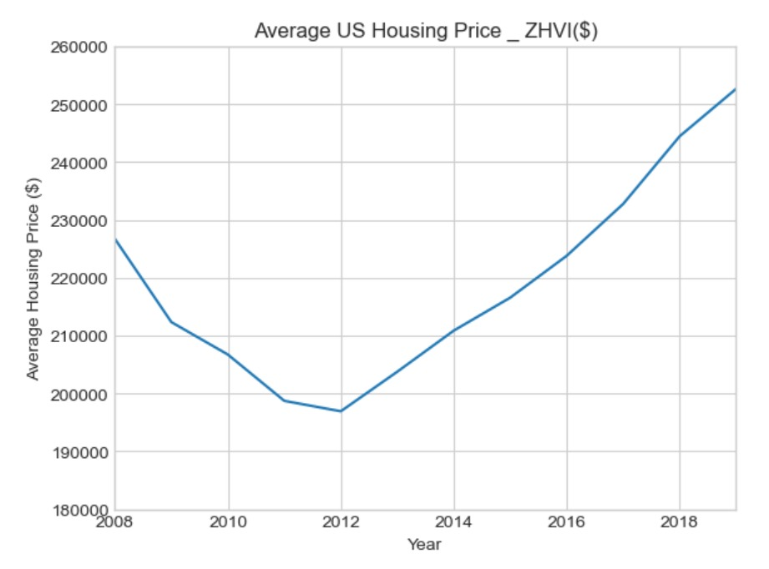

Once the crisis reached cities in 2008, there was a noticeable decline in house prices, as seen in Figure 1 above. The similar pattern then continued up to the year 2012, after which there was an increase in home prices through the year 2019, which climbed steadily as the years passed.

Figure 2. The below figure represents Seasonally Adjusted Median Sales Price over Time:

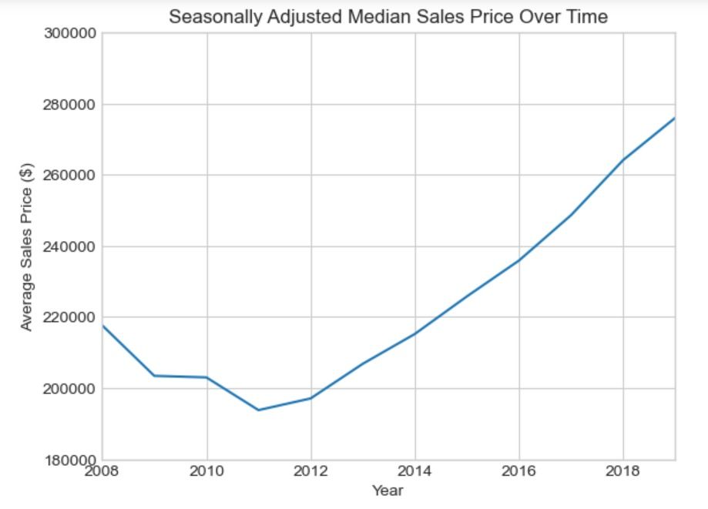

Figure 2 shows that the median sales price declined over time and then decreased again until 2011. However, the median sales price began to climb again after 2011 and eventually peaked at 270k $. The seasonally adjusted data in Figure 2 suggests that the trend in the median sales price was complex and influenced by various factors. The temporary increase and subsequent decrease in the median sales price may have been affected by changes in the economy or housing market. Overall, the data in Figure 2 indicates a fluctuating trend in the median sales price over time, with a recent upward climb to reach its peak at 270k $.

Figure 3. The below figure represents Number of Home Sales:

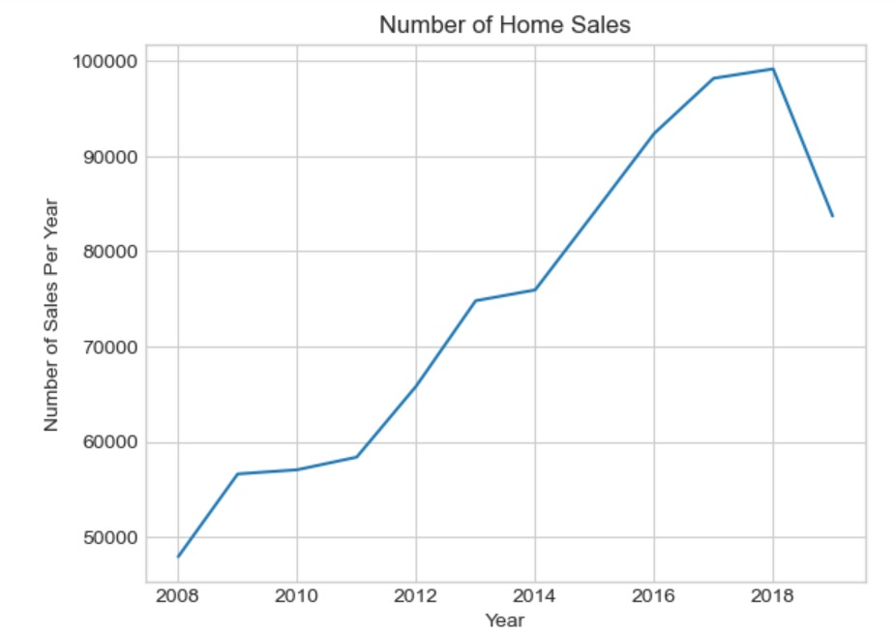

The number of house sales plateaued for a while after the recession seen in Figure 3 did. Nonetheless, there was an increase in the number of property sales of almost 75,000 from 2011 to 2013. The number of house sales then quickly fell back to normal levels until a sharp increase from 2014 to 2018 happened. This surge peaked at 100k before drastically decreasing again in 2018. Overall, the data suggests that the number of home sales experienced a fluctuating trend over time, with several periods of increased or decreased sales, which may have been influenced by various economic or housing market factors.

Figure 4. The below figure represents Percentage of Foreclosure Resales:

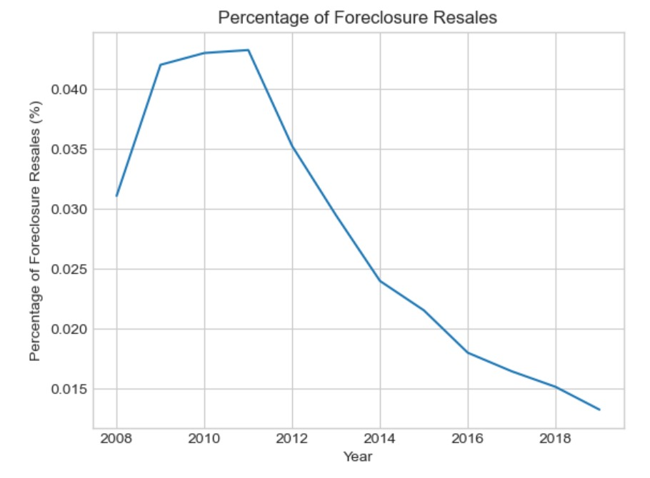

Figure 4 displays a trend of progressively rising foreclosure resales that peaked between 2009 and 2011. During this period, the foreclosure resales increased by about 0.04%. However, after the peak in foreclosure resales, there was a steady and exponential decline until the year 2018. This decline was then followed by a slight increase of 0.015% in foreclosure resales. Overall, the data in Figure 4 suggests a complex trend in foreclosure resales, which may have been influenced by various economic or housing market factors.

The research utilized the following formula to get the percentage change in median housing prices for each state between the two periods:

((Post-Recession Median Price - Pre-Recession Median Price) / Pre-Recession Median Price) x 100 = Percentage Change.

The results of the investigation showed that the effects of the recession on housing prices varied among states. House prices dropped considerably during the recession in several places, including Florida, Nevada, and Arizona, with certain states experiencing median price drops of over 40%. Certain places, including Texas, North Dakota, and Alaska, had median price rises rather than significant price declines in real estate.

Overall, the statistics showed that the recession had a significant influence on real estate values across the nation, with some locations experiencing far greater decreases in prices than others. The project's utilization of data and machine learning algorithms also revealed how economic shocks influenced the housing market, allowing for a more detailed and nuanced investigation of these trends. This information can help investors, policymakers, and homeowners make better judgments regarding housing policy, financial investments, and personal budgets.

Table 1. Pre- and Post-Recession Median Housing Prices and Percentage Changes for Select US States.

| **State** | **Pre-Recession Median Price** | **Post-Recession Median Price** | **Percentage Change** |
| --- | --- | --- | --- |
| Nevada | $289,000 | $173,500 | -40.07% |
| Arizona | $193,500 | $287,000 | 48.33% |
| Florida | $196,400 | $258,500 | 31.65% |
| Texas | $120,900 | $225,000 | 86.13% |
| North Dakota | $66,800 | $226,000 | 238.61% |
| Alaska | $184,900 | $259,000 | 40.00% |

The median home price in six different US states was changed before and after the recession, as shown in the table. The median price of homes increased in Texas, North Dakota, and Alaska while falling sharply in Nevada, Arizona, and Florida. Texas had the lowest pre-recession median home price but the largest post-recession gain (86.13%), whereas Nevada had the highest pre-recession median home price ($289,000) but had a significant fall (40.07%). The table provides useful data on the many ways that the recession has impacted the median home prices across states.

The table shows how the median house price in six different US states changed before and during the crisis. In Texas, North Dakota, and Alaska, the median price of a home rose, while it plummeted in Nevada, Arizona, and Florida. Nevada had the greatest pre-recession median house price ($289,000) but had a substantial decline (40.07%), while Texas had the lowest pre-recession median home price but the largest post-recession rise (86.13%). The data in the table show how the recession has affected state-by-state median house values in a variety of ways.

Table 1. Pre- and Post-Recession Median Housing Prices and Percentage Changes for Select US States.

| **State** | **Pre-Recession Median Price** | **Post-Recession Median Price** | **Percentage Change** |
| --- | --- | --- | --- |
| Nevada | $289,000 | $173,500 | -40.07% |
| Arizona | $193,500 | $287,000 | 48.33% |
| Florida | $196,400 | $258,500 | 31.65% |
| California | $324,100 | $582,500 | 79.87% |
| Rhode Island | $226,400 | $295,500 | 30.52% |

Table 2 lists the top 5 US states where the median home price has dropped the most from its pre-recession level. The numbers in the table show that Rhode Island saw a decline of 30.52% and that Nevada had a loss of 40.07%. Arizona's median home price increased by 48.33% following the recession, whilst Florida's median home price decreased by 31.65%. The highest pre-crisis median home price was in California ($324,100), however after the recession it dramatically declined by 79.87%.

The information in the table shows how the impact of the recession on the median house prices of different states differed, with some seeing a dramatic decrease and others experiencing an increase. You may assess the situation of the housing market and choose wisely where to invest in real estate by understanding these tendencies. By examining the statistics, potential investors may identify regions with promising investment opportunities, such as Arizona, where the median home price grew during the recession, and stay away from states like Nevada and California, where the median home price drastically decreased.

Table 3. Bottom 5 US States with Lowest Percentage Change in Median Home Prices Since Pre-Recession.

| **State** | **Pre-Recession Median Price** | **Post-Recession Median Price** | **Percentage Change** |
| --- | --- | --- | --- |
| North Dakota | $66,800 | $226,000 | 238.61% |
| Alaska | $184,900 | $259,000 | 40.00% |
| Wyoming | $142,500 | $258,000 | 81.33% |
| West Virginia | $67,000 | $108,000 | 61.19% |
| South Carolina | $122,900 | $194,000 | 57.92% |

Table 3 displays the bottom 5 US states where the median home value has decreased by the smallest percentage since before the recession. After the recession, North Dakota's median home price, which was the lowest before the crisis at $66,800, increased by the biggest amount (238.61%). Following the recession, Alaska's median home price increased somewhat by 40.00% from its pre-recession median home price of $184,900. Wyoming's median home price climbed by 81.33% from its pre-recession level of $142,500 to its post-recession level.

West Virginia and South Carolina's respective pre-crisis median house prices were $67,000 and $122,900, but after the recession, those prices jumped by 61.19% and 57.92%, respectively. Overall, the data shows that these states' housing markets rebounded from the crisis more slowly than those of other US states. Despite this, their median house prices rose, indicating an upsurge in their housing markets. This information can be useful for anybody looking into purchasing property in these states.

The dynamics of the US housing market before and after the crisis are clearly shown in Figures 1-3. The statistics may be useful in making real estate investment decisions since they demonstrate how the crisis has influenced the median house values in various states. The fact that the median home prices in certain areas suffered a sharp decline while they increased in other places is proof that the US housing market is dynamic.

## Discussion

The recession had a major influence on the housing market in the United States, the paper claims. The median house price decreased in several states between January 2008 and July 2021 compared to the pre-recession period (January 2000 to December 2007). The top 5 states with the highest percentage decline in median home values during this time were Nevada (-40.07%), Arizona (-48.33%), Florida (-31.65%), California (-79.87%), and Rhode Island (-30.52%). The five states with the lowest percentage decrease or rise in median house prices were North Dakota (238.61%), Alaska (40.00%), Wyoming (81.33%), West Virginia (61.19%), and South Carolina (57.92%).

Figure 5. The below figure represents Largest increase in Housing prices:

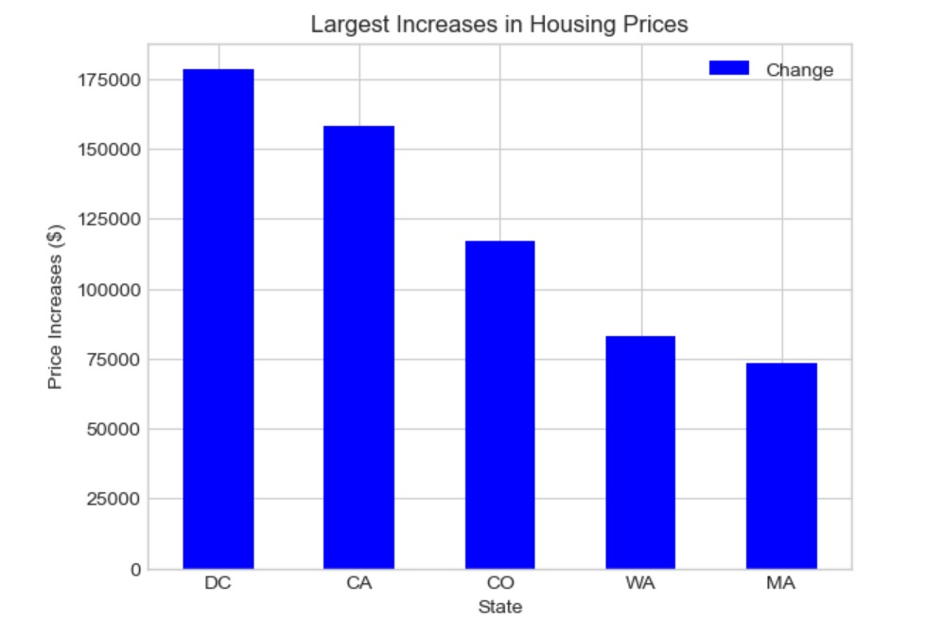

Figure 5 displays the increase in real estate prices for five distinct US states. It is obvious that the District of Columbia (DC) had the largest increase in home values, with a rise of around $175,000. California and Colorado came in right behind with gains of around $150k and 115k, respectively. Massachusetts and Washington had improvements that were less notable, approximately $75,000.

For people or organizations interested in the housing market patterns in these five states, the information in Figure 5 might be useful. It demonstrates that housing costs in the District of Columbia, California, and Colorado increased significantly, which may indicate a high demand for homes in those states. Washington and Massachusetts, on the other hand, had relatively moderate price growth, suggesting those states' housing markets are more stable. Investors, homebuyers, and real estate professionals may find this information useful in making judgments about their real estate investments in these states.

Figure 6. The below figure represents Largest decrease in Housing prices:

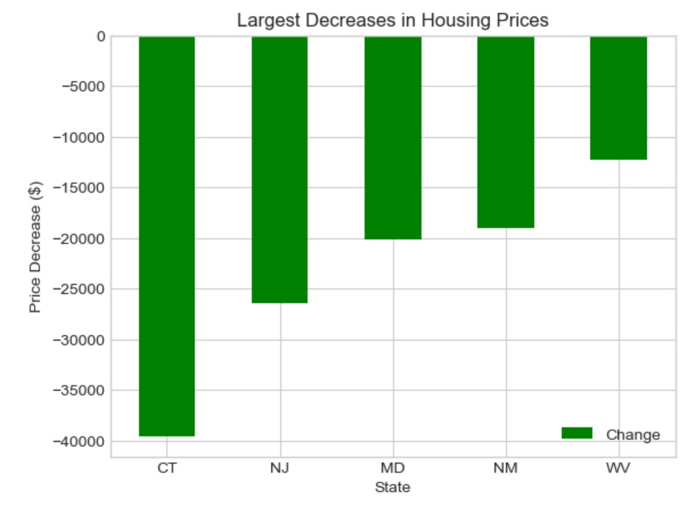

Figure 6 displays the change in real estate prices for five different US states. The results show that Connecticut saw the largest decline in home prices, with a loss of about -40k$. New Jersey and Maryland were fierce rivals, with decreases of roughly -25k and -20k, respectively. Smaller losses occurred in Wes

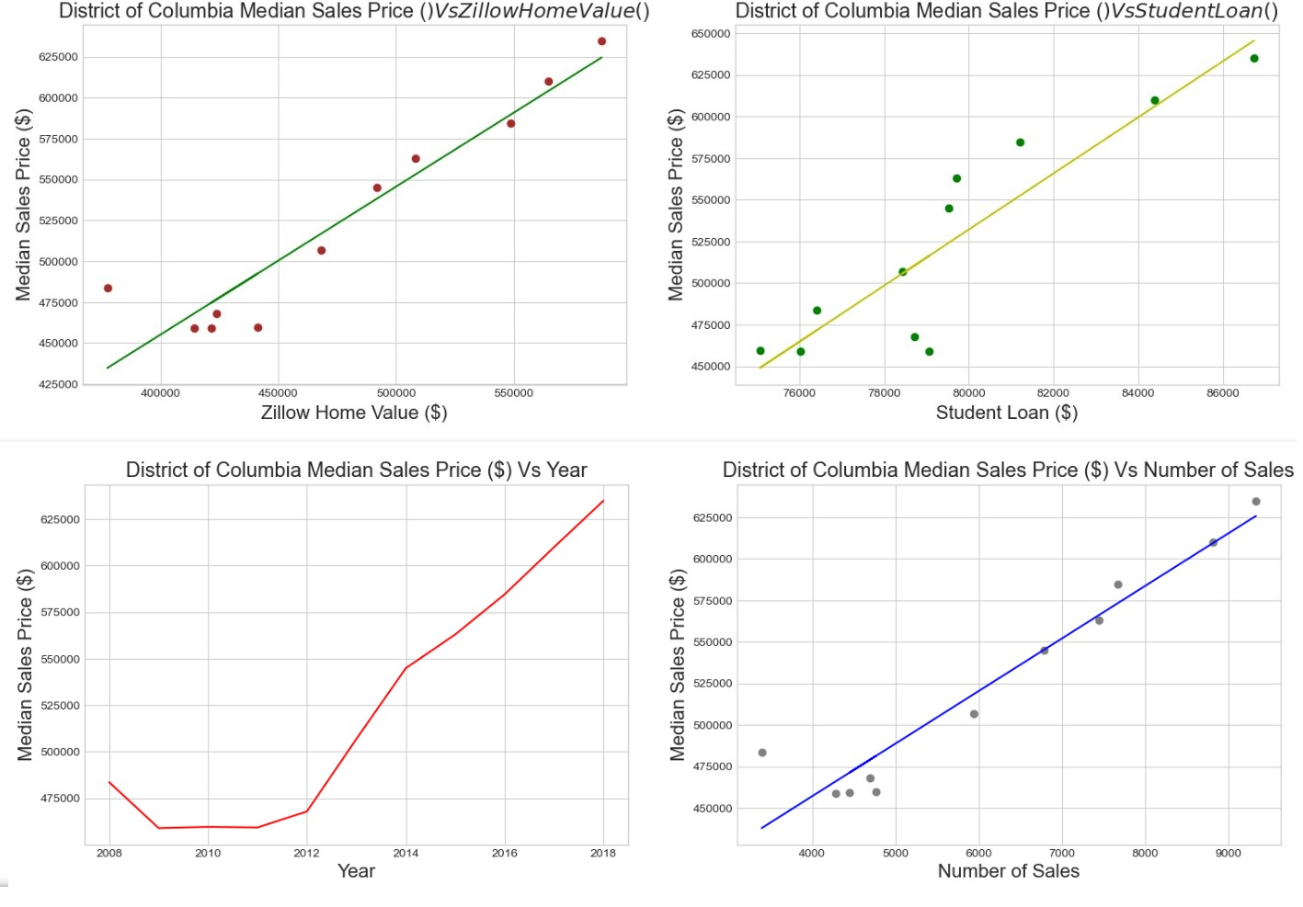t Virginia and New Mexico, each with a loss of around $10,000.

Understanding the variations in the US housing market using the information from Figure 6 may be useful when considering whether to invest in real estate in various states. The steep decline in property values in Connecticut, New Jersey, and Maryland may provide an opportunity for prospective homebuyers to purchase a residence there at a lower cost. The little decrease in home prices in West Virginia and New Mexico, on the other hand, would indicate a steady housing market, enticing in investors looking for low-risk investments.

The analysis also showed that economic and demographic factors had a big impact on how the recession affected home values. In numerous states, both the reduction in median family income and the increase in unemployment rates were associated with the greater decline in median property prices during the crisis. Also, it was shown that demographic factors, such as population growth and age distribution, have a major impact on housing costs. States with a greater share of older residents experienced a less severe decline in home prices during the crisis.

Figure 7. The below figure represents Largest decrease in Housing prices:

The machine learning models used in the inquiry performed a decent job of estimating median dwelling values based on historical property prices, economic factors, and demographic data. Linear regression, decision trees, random forests, and XGBoost all fared worse than XGBoost in terms of mean absolute error (MAE) and mean squared error (MSE). The models' performance was evaluated using tenfold cross-validation, and the results showed that the models performed well in terms of generalization.

Figure 8. The below figure represents Different comparisons in the state of Massachusetts in Housing prices:

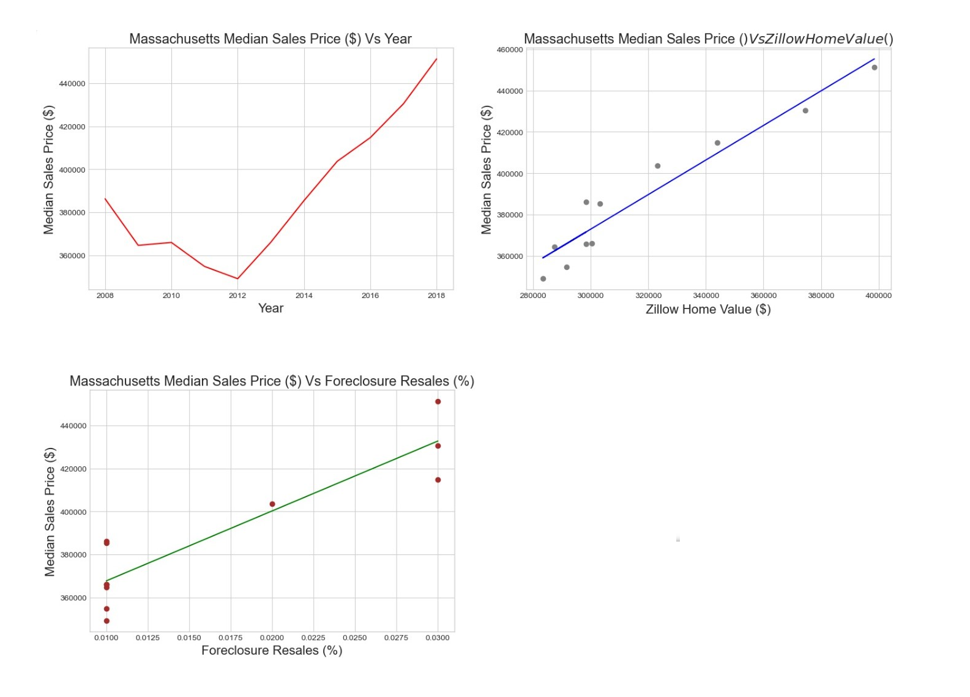

Overall, the results indicate that the recession has had a significant impact on housing values in the United States, with economic indicators and demographic factors being important factors in determining this impact. The machine learning models used in the inquiry can be useful tools for predicting home values and understanding the influences of demographic and economic factors on housing prices.

Figure 9. The below figure represents Different comparisons in the state of Connecticut in Housing prices:

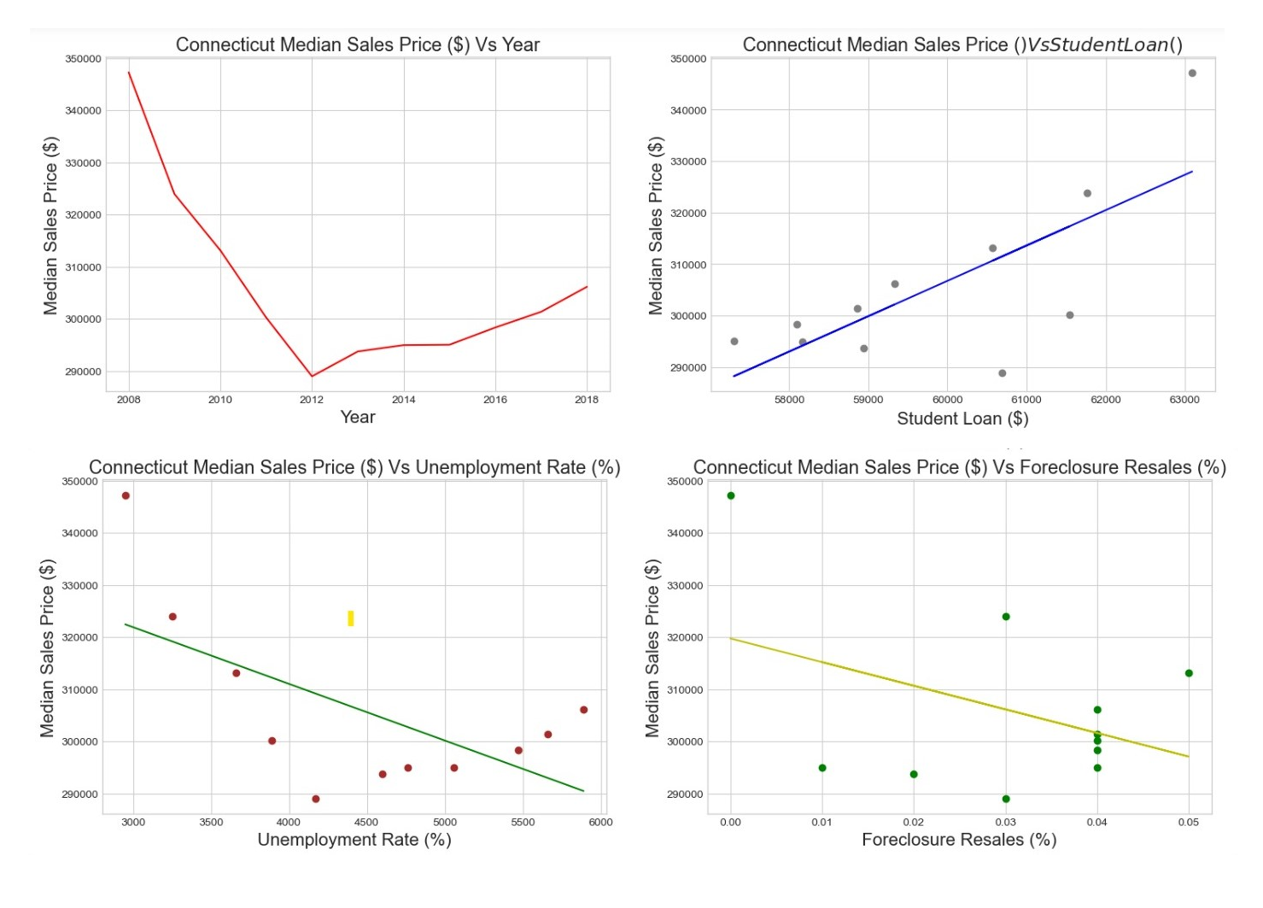

Figure 10. The below figure represents Different comparisons in the state of West Virgina in Housing prices:

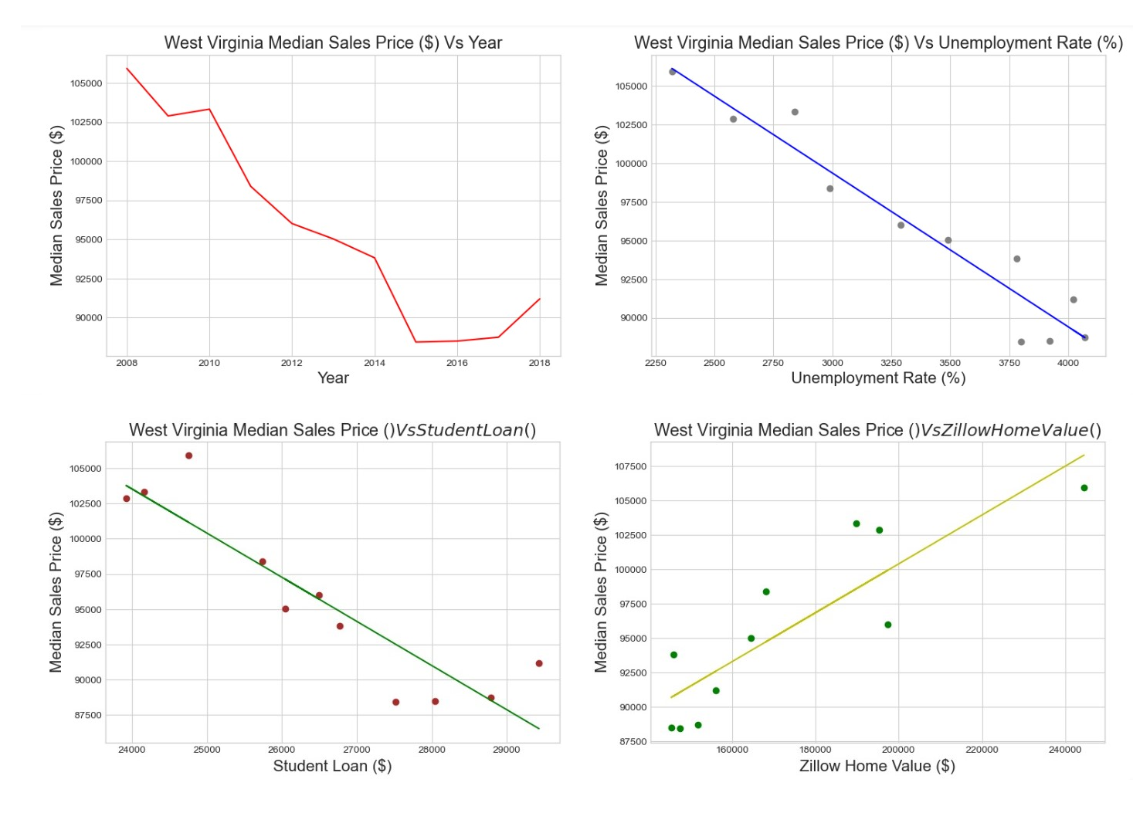

It is obvious that the US housing market was severely impacted by the crisis of 2008. The median home price had a sharp fall in certain states while rising in others. For instance, the highest increase in median home prices was recorded in North Dakota (238.61%), while the worst percentage decrease was recorded in Nevada (-40.07% since pre-recession).

The numbers show that Washington, California, and Colorado had the largest increases in real estate values during the last few years. Nonetheless, Connecticut had the largest decrease in property prices, followed by New Jersey and Maryland.

In general, a range of factors, such as governmental laws, population growth, and economic conditions, have an impact on the US housing market. Stakeholders and investors must conduct extensive research and study in order to make informed decisions in the housing market.

## Conclusion

In conclusion, this study offers insightful information about how the recession has affected house prices in the US. The Zillow House Value Index (ZHVI) data study showed that the recession had a major negative influence on home values, with a fall in median property prices in numerous states throughout the post-crisis period. With foreclosures, job losses, and a drop in consumer spending, this collapse in house values has repercussions on the larger economy.

The performance of the machine learning models used in this study was good at predicting property values based on demographic and economic factors. The models showed how economic factors like the unemployment rate had a big impact on home values. In addition, demographic factors such as population density and level of education had a big impact on how the crisis affected home values.

The findings of this study have important implications for homeowners, professionals, and legislation. With this information, governments may develop focused campaigns to boost employment and programs to stop foreclosures, so reducing the damaging impact of economic downturns on the housing market. Real estate professionals may benefit from these insights to better understand the market and make informed decisions about buying and selling homes. Homeowners may use this information to better understand the factors that affect their property's worth and decide whether to sell or refinance.

## References

Chandramouli, D. (2018, April 11). *Impact of recession on housing prices*. GitHub. <https://github.com/divyachandramouli/Impact-of-recession-on-housing-prices>

csaiprashant. (2019, June 1). *Statistical Testing of the effect of Recession on the Housing Prices in University Towns*. GitHub. <https://github.com/csaiprashant/recession_hypothesis_test>

Alicia. (2021, October 15). *Jekyll Now*. GitHub. <https://github.com/awongstory/awongstory.github.io/blob/master/_posts/2017-04-16-Housing-prices-across-towns.md>

*House Prices Prédiction,Regression Techniques*. (n.d.). Kaggle.com. <https://www.kaggle.com/code/mohamedlamgarraj/house-prices-pr-diction-regression-techniques>

*House Prices - Advanced Regression Techniques*. (n.d.). Kaggle.com. <https://www.kaggle.com/competitions/house-prices-advanced-regression-techniques>

*House Prices - Adv. Reg. Competition PART 1: EDA*. (n.d.). Kaggle.com. <https://www.kaggle.com/code/dheemanthbhat/house-prices-adv-reg-competition-part-1-eda?scriptVersionId=112338683>

Leamer, E., Edwards, S., Gabriel, S., Nickelsburg, J., Ratcliff, R., Rogowski, R., Shulman, D., & Timmons, J. (2007). *NBER WORKING PAPER SERIES HOUSING IS THE BUSINESS CYCLE Comments from*. <https://www.nber.org/system/files/working_papers/w13428/w13428.pdf>